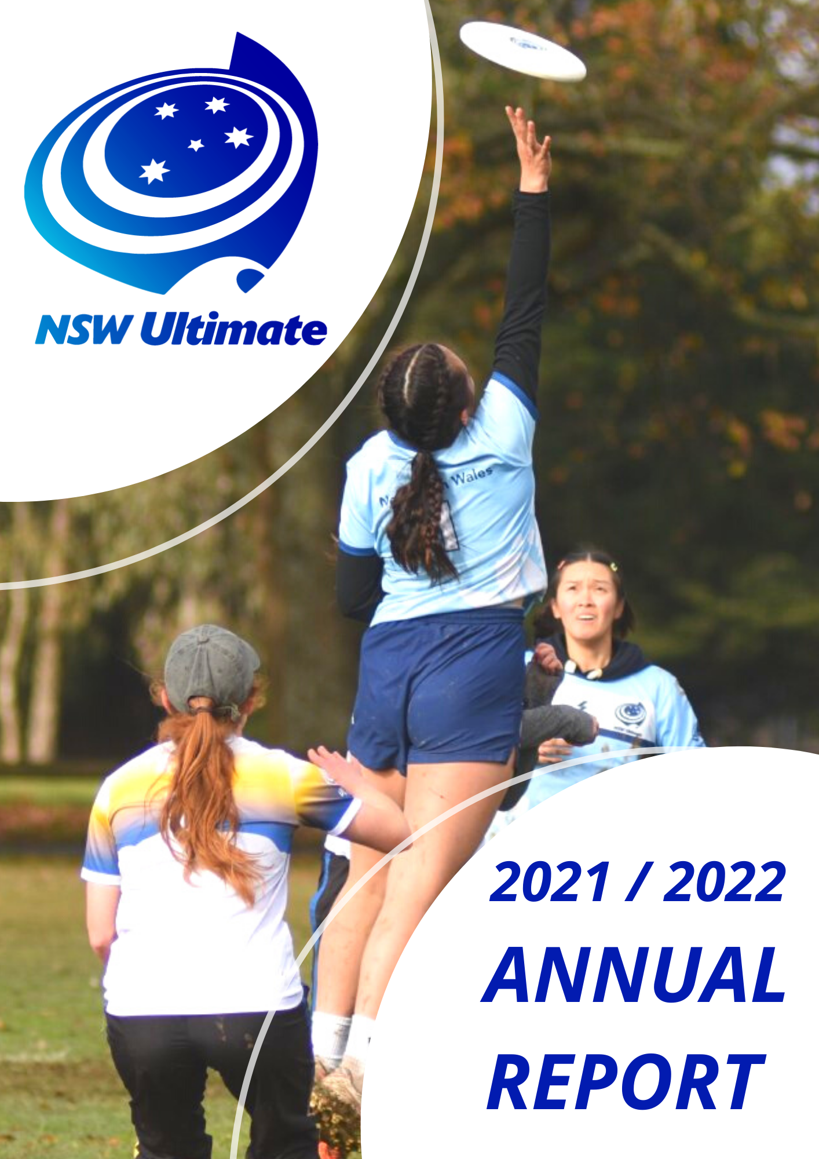

NSW Ultimate

Affiliated Clubs:
Bench Ultimate
Barefoot Bandits
Darlinghurst Ultimate Frisbee Federation Inc.
Dubbo Ultimate Frisbee Federation Inc.
Dungog Frisyay
Greater Western Sydney Women’s Ultimate Inc.
Hills Ultimate Frisbee Association Inc.
Inner West Ultimate Inc.
Manly Ultimate Inc.
NACE Ultimate Inc.
Newcastle I-Beam
Newcastle Pie Wagon Ultimate Club
Newcastle Ultimate Inc.
Northern Suburbs Ultimate Inc.
Orange NSW Ultimate
Rogue Women's Ultimate Club Inc.
South West Ultimate Inc.
Sugar Magnolias
Sunder Ultimate
Ultimate Volleyball Club
Western NSW Ultimate Frisbee Inc.
Western Sydney Ultimate
Wollongong Ultimate Frisbee

NSW Ultimate Executive Committee (from May 2022)
President: Millicent Crowe
Vice President: Kylie O’Brien
Secretary: Frank Milthorpe
Director of Clubs: David O’Brien
Director of Events: Monica Chang
General Member: Luke Prosser
General Member: Sam Armes

NSW Ultimate Executive Committee June 21-May 22
President: Kylie O’Brien
Vice President: Luke Prosser
Secretary: Frank Milthorpe
Director of Clubs: David O’Brien
Director of Events: Monica Chang
General Member: Millicent Crowe
General Member: Sam Armes

NSW Ultimate Staff:
Emily Goldstiver - Bookkeeper
Nicholas Lelli - Development officer

NSW Ultimate Officers:
Jack Gray (Equipment Officer),
Alex Pentony Vran (Web Officer??)

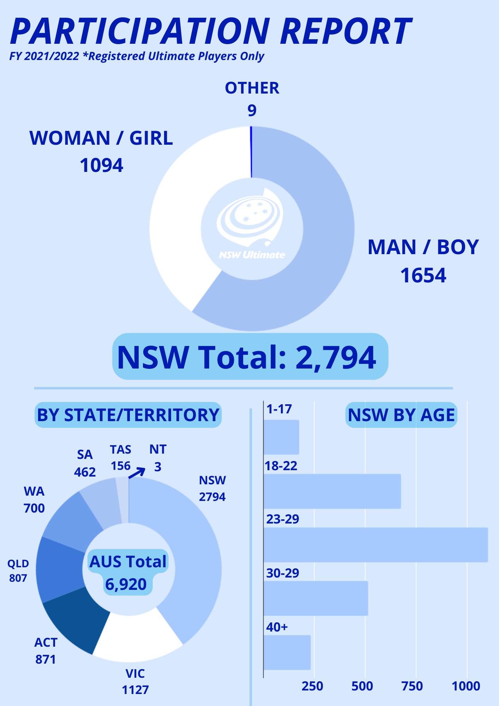

PRESIDENT’S REPORT (Kylie & Millie)
The 2021-2022 Year was a turbulent one, with rain and Covid restrictions affecting participation in July through to October. This caused the cancellation of 2021 Mixed State Championships, 2021 Mixed National Championships, 2021 Senior and Junior State School Championships, U18 & U22 National Championships and reduced in-school coaching for Term 3 and 4.
After the resumption of activities, the ulti-mates program saw growth in 2022 with term 1 having 17 schools participate and term 2 having 24 schools participate. The ulti-mates program reached over 10,000 students and engaged over 15 coaches.
NSWU held two rounds of grants for club and grassroot development. This saw multiple clubs across the state implement new initiatives to increase participation of ultimate players across the State.
Development Grant Round 1 (awarded December 2021):
- Orange Ultimate for $1,000 to run a tournament and an indoor competition
- Darlinghurst Ultimate Frisbee Federation for $1,500 to run a new 5v5 league
- Hills Ultimate for $4,000 to run coaching clinics for women
Development Grant Round 2 (awarded June 2022):
- Wollongong Ultimate for $1500 to run Women's League
- Wollongong Ultimate for $500 to run Skills for University students
- Newcastle Sugar Magnolias for $2735 to run Womens Come and Try Community Day
- North Sydney Ultimate for $1500 to run Youth Ultimate
- Byron Ultimate for $1000 to run Establish New Social League
- Volleyball Ultimate Club for $500 to run Skills for University students
- Orange Ultimate for $1000 to run Establish New Social League
- Hills Ultimate for $1000 to run Youth Ultimate
- Manly for $2000 to run School Holiday Camp
- Manly for $3000 to run Youth Ultimate League

There was a transfer of Presidency in May 2022 from Kylie O’Brien to Millicent Crowe.

EVENTS REPORT (Mon & Nic)
2021 Mixed State Championship
Due to COVID restrictions, the Mixed State Championships 2021 was cancelled.
2022 Regional Championships
Regionals 2022 was held in Raymond Terrace (Newcastle, NSW) hosted by Newcastle Pie Wagon Ultimate Club. There were 29 teams present who competed over 2 days on 26/27 of February 2022.
Congratulations to all teams that qualified and competed at the Australian Division 1 and 2 National Championships.

Open Teams (Final Placing) | Women’s Division (Final Placing)
Sunder Slice | GWS Blaze
Sunder Dice | Manly Mavericks
Fyshwick United | Factory Flash
Krank | Sugar Magnolias
I-Beam | Surge
Status Quo | NSU Aurora
Manly Mullets | Hills
Branch A | Underground
Fyshwick Unit | Manly Rollers
Ironbark | Factory Frenzy
NSU Borealis | Branch W
Newcastle U-Beam | Tempest
Branch B | Zesty Chilly
Manly Muckerels
Fyshwick Uni

Club Tournaments
Many braved the heat again to get to Newcastle Gold Cup and super doopers again.
InnerWest/Manly Take off, took off for another year with great success.
Bathurst Stampede stomped in again bigger than ever.
Manly introduced the Queenscliff Classic which is another good lead up to the mixed season.
The ever popular Gong Classic was back, although really wet weather made it a one day tournament, it's always one to remember.
Duff held their Sydney Winter series giving mixed teams a good run around.
Another successful tournament to dominate summer days is Gongmama with players from NSW, VIC and ACT attending
Longest Day, without the gale force winds this time rounding the year nicely with some beach action.

The coming years will bring more teams and events to the calendar. We are also revising our state event hosting and compiling resources for tournament hosting for clubs in the new year and looking forward to contributing to growing our sport and network.

Monica
Director of Events

2022 State Representative Teams

The under 18 and under 22 championships were last held in 2019 and have been cancelled due to covid. This year we have prepared 5 teams to attend the Australian Youth and Under 22 National events that were held in July 2022.

NSW Ultimate selected staff and players for 3 U22 and 2 U18 NSW teams. The athletes and staff were fine ambassadors for our state, finishing with the following results:

Team | Placing | Spirit
U22 Women | 2nd | 2nd
U22 Mixed | 1st | 4th
U22 Open | 1st | 3rd
U18 Women | 1st | 1st
U18 Open | 1st | 1st

Congratulations to our teams for such a successful year and for a return to the National Championships.

Our 2022 coaches were … and our 2022 team managers were … . These are volunteer positions, and we thank our coaches for the significant time they spent in these campaigns and ensured the teams could succeed in having fun and playing high level ultimate. For a full list of all players involved in the campaign please head here.

2021 State School Championships
These were not run in 2021 due to covid restrictions and change in calendar date.

CLUBS REPORT (Dave)
- Bryon Ultimate

TREASURER’S REPORT
We currently do not have a treasurer. As such our Accounts Manager, Emily Goldstiver has been providing oversight of our finances. Through the 21/22FY NSW Ultimate has benefitted from several covid Government Grants which offset the decreased revenue. NSW Ultimate has a significant profit margin which we are investing in ensuring the growth and sustainability of Ultimate in NSW.

DEVELOPMENT REPORT

The 2021/22 financial year was a positive period for growth and development despite the pandemic and torrential rain. Through further lockdowns in the second half of 2021 and exceptional rain in the first half of 2022, NSW Ultimate staff and volunteers pushed to deliver a number of school, club and representative programs across the state.

Club Youth

Youth and junior club programs are one of the most important steps in the development pathway. In the 2020/21 summer Manly, Hills and Northern Suburbs Ultimate all ran programs for junior and youth players.

Running these programs can be hugely beneficial club. They can help provide a playing and coaching pathways for club members, they can increase overall club participation, and can be an additional source of income.

We encourage clubs to consider having a program for juniors and help create the next generation of ultimate players in clubs. NSW Ultimate can help facilitate junior programs.

Sporting Schools

Sporting Schools is a nationwide government funded program that provides grant funding directly to schools for students in years K- 8. This funding is to be expended on sport coaching services and equipment. Schools can only purchase coaching services and equipment from sports included in the Sporting Schools program. Ultimate gained inclusion into the program in Term 3 2021. Ulti-Mates is Ultimate Australia’s program for K-6.

Ulti-Mates has been delivered across NSW by our network of casual coaches and our partnered private provider Gecko Sports. Ulti-Mates can also be purchased by schools as a Teacher delivered package, enabling teachers to run the program at their school without an external coach. Since its introduction in Term 3 2021, Ulti-Mates has been delivered to 10,457 primary school students in NSW.

Before ultimate was accepted in sporting schools, NSW and other states had limited formal coaching opportunities for primary schools. Sporting schools has catalysed a large increase in the amount of students that are exposed to ultimate each term.

The surge of primary school coaching in NSW has allowed NSW Ultimate to recruit and train a workforce of casual coaches that deliver our programs in schools across the state. The scheduling, training and recruitment of new coaches has become a key project for the organisation. We believe the program is a valuable investment that will hopefully increase the amount of kids playing ultimate at their primary school, highschool and eventually local club.

High Schools

The Covid lockdowns significantly impacted our ability to run our usual senior and junior high school state championships events. Both events were cancelled in the last financial year and instead were run in September 2022.

Our High school State Championships, both senior and junior will likely run in term 3 each year moving forward. This is to align the events to become promotional opportunities for our summer youth club programs.

